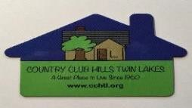

2026
CCHTL Neighborhood Association Garage Sale
Thurs, June 4; Fri, June 5; Sat, June 6
$5.00 for all three days

REGISTRATION FORM
Please return to Kathy Bifluco by Friday, May 29th

Days of Your Sale_______________________
(Check all that apply)
$5.00 for all three days

Thursday (June 4th)  Friday (June 5th)  Saturday (June 6th)

Name:

Address:

Phone: Email Address:

Your Highlighted Items:

Please make your $5.00 payable to: “CCHTL”
By Friday, May 29
Mail to: Kathy Bifulco, 768 Yorkshire Drive, Lima, OH 45804
Or use

ZELLE: cchtlneighborhood@gmail.com
:
cchtlneighborhood@gmail.com

